Right Hypochondriac  X X X | Liver  Gallbladder  Small intestine  Ascending Colon  Transverse Colon  Spleen  Right Kidney  General inspection  - Colour e.g. Jaundice  - Ask about pain and note discomfort  - Spider-naevi throughout  - Note and describe vomit  Hands  - Leukonychia – White spotting in finger nails  - Koilonychia – Inwards spooning of finger nails  - Clubbing  - Anaemic palmar creases  - Palmar erythema  - Dupuytren’s contracture – Inwards flexion of medial fingers  - Hepatic flap  - Pulse rate, rhythm and strength  Neck  - Jugular venous pressure  Face and Eyes  - Conjunctiva (Jaundice)  - Anaemia  - Mouth ulcers  - Dentition  - Dehydration – Lips and tongue  - Tongue disorders – e.g. Atrophy, Polyps  Lymph Nodes  - Occipital  - Pre and Post-auricular  - Submandibular  - Submental  - Tonsillar  - Anterior and posterior cervical  - Supraclavicular including scalene  Abdomen – Inspection  - Symmetry and shape – obvious lumps, bulging masses or distension  - Pulsations and Peristalsis  - Venous distension  - Discolorations – Bruise like shapes either central (Cullen’s) or dispersed (Grey turner’s)  Abdomen – Palpation  - Light and Deep – All 9 areas  - Rebound tenderness  - Ballot Kidneys  - Liver  - Spleen  - Bladder  - Aorta  Abdomen – Percussion  - Liver  - Spleen  - Bladder  - Shifting dullness  - Fluid thrill  Abdomen – Auscultation  - Bowel sounds and note location e.g. Descending colon  - Aorta  - Renal arteries – 4cm~ latero-superior from naval  - Liver bruits – Auscultate over liver
Epigastrium  X X X | Oesophagus  Stomach  Liver  Pancreas  Small intestine  Transverse colon  Right and left kidneys and ureters  Spleen
Left Hypochondriac  X X X | Stomach  Liver (tip)  Pancreas (tail)  Small intestine  Transverse colon  Descending colon  Left kidney  Spleen
Right Lumbar  X X  X | Liver (tip)  Gallbladder  Small intestine  Ascending colon  Right kidney
Umbilical  X X X  X | Stomach  Pancreas  Small intestine  Transverse colon  Right and left kidneys and ureters
Left Lumbar  X X X  X | Small intestine  Descending colon  Left kidney tip
Right iliac  X X  X | Small intestine  Appendix  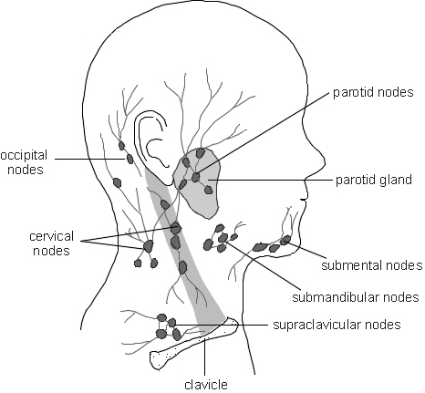Cecum  Ascending colon  Right ovary and fallopian tube
Hypogastric  X X X  X | Small intestine  Sigmoid colon  Rectum  uterus  Right and left ovaries and fallopian tubes  Right and left ureters  Bladder  Prostate
Left iliac  X X X  X | Small intestine  Descending colon  Sigmoid colon  Right and left ovaries  Left fallopian tube

